

Programming Applications and Frameworks

Group Project – **Overall Group Report**

**SellNBye Online Shopping System**

Batch : DS-WE

Group Number : 06

Link for Repo : <https://github.com/hirunip/PAF_GROUP_PROJECT_DS.git>

**Members’ details**

|  |  |  |
| --- | --- | --- |
| **Student ID** | **Name** | **Workload** |
| IT17130912 | Kumari D.M.S.S. | Login and Registration |
| IT17120630 | Kasthuriarachchi H.P. | Product Management |
| IT17031226 | Nimasha Padmakumara | Shopping Cart |
| IT17118378 | Subasinghe A.S. | Payment Management |

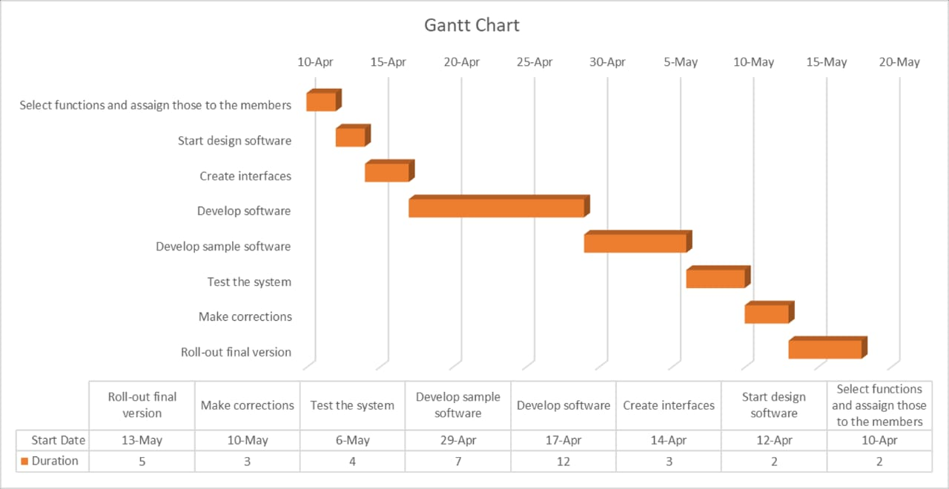

**System’s overall Usercase design**

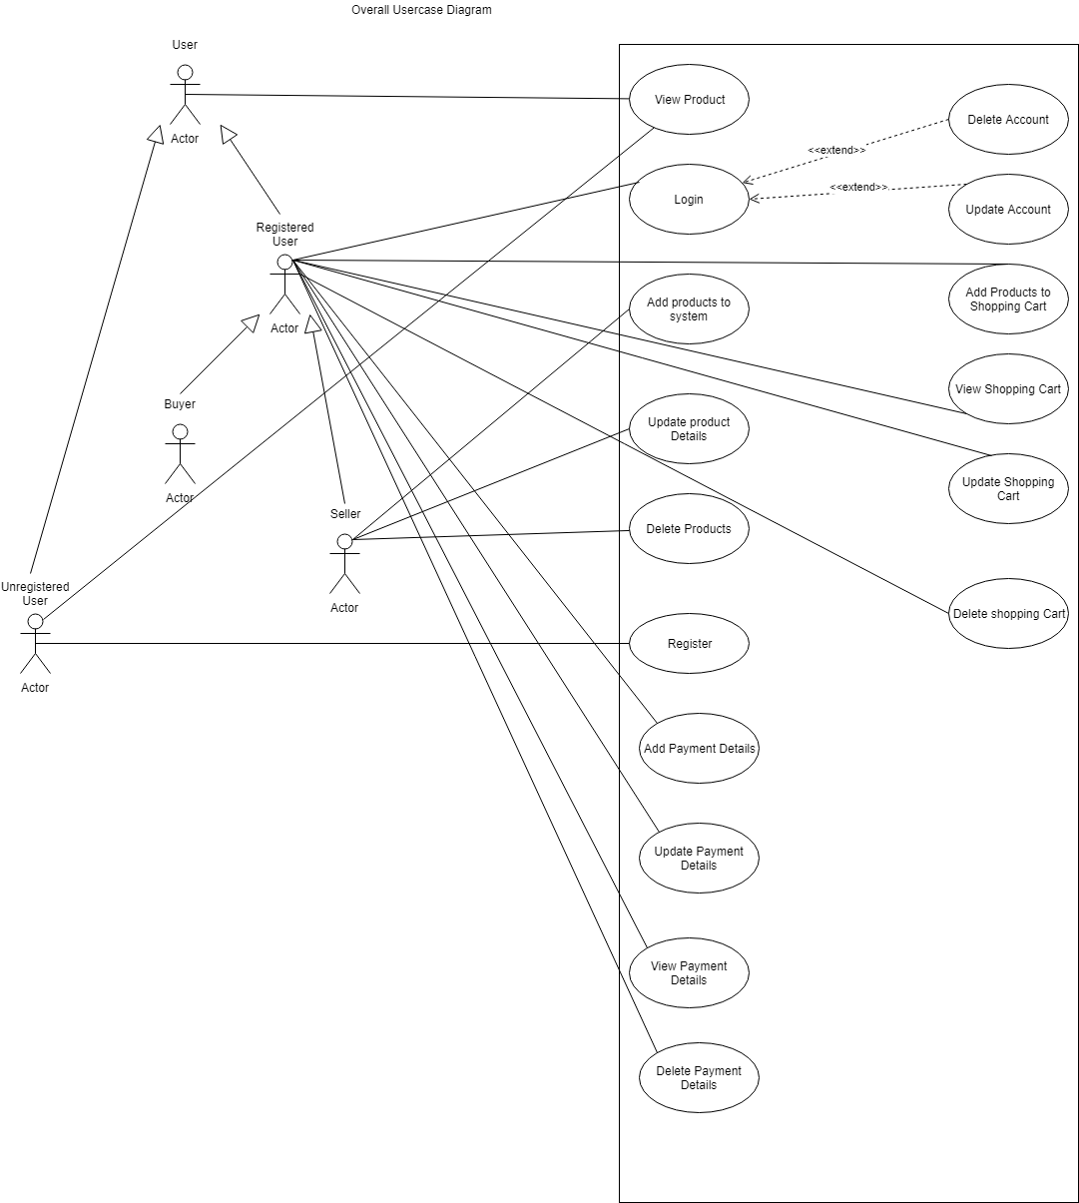

**Overall Activity Diagram**

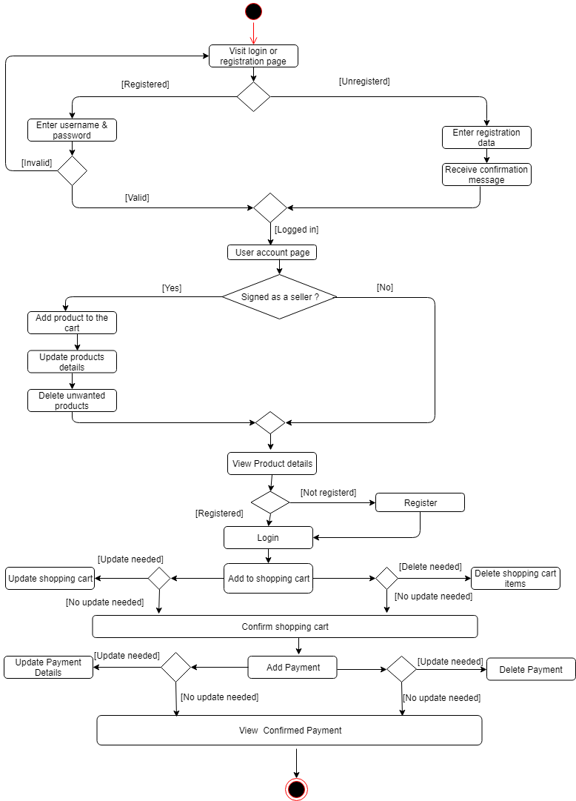

**Onion Diagram**

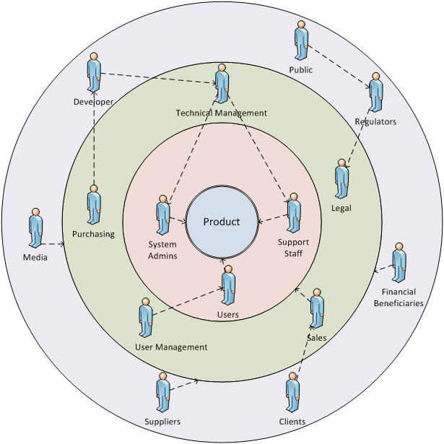

**Requirements Analysis**

|  |  |  |  |
| --- | --- | --- | --- |
| **Function** | **Functional Requirements** | **Non-functional Requirements** | **Technical Requirements** |
| Login and Registration | Login  View details  Fix details | Scalability  Availability  Data Integrity  High security | User supportive  User friendly |
| Product Management | Add products  View Products  Delete Products  Update Details | Usability  Maintainability  Availability | User friendly  Well supported  Accessibility |
| Shopping Cart | View cart  Update cart  Delete items  Add items | Serviceability  Availability  Usability | High availability  User friendly  Well supported |
| Payment Management | Add payments  View payments  Delete payments  Update payments | Performance  Security  Privacy  Response time | Well supported  User friendly  High reliability |

**SE methodology**

***Agile Method***

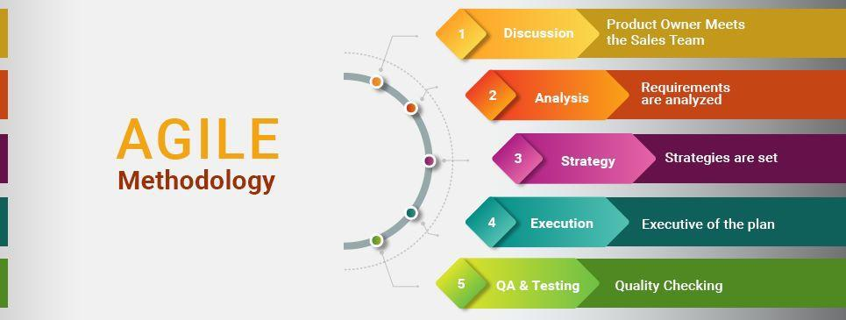

* Agile project management is an iterative approach to managing software development projects that focuses on continuous releases and incorporating customer feedback with every iteration. This method assists teams in responding to the unpredictability of constructing software. It uses incremental, iterative work sequences that are commonly known as sprints.
* In the Agile methodology, each project is broken up into several ‘Iterations’.
* All Iterations should be of the same time duration (between 2 to 8 weeks).At the end of each iteration, a working product should be delivered.
* In simple terms, in the Agile approach the project will be broken up into 10 releases (assuming each iteration is set to last 4 weeks).
* Rather than spending 1.5 months on requirements gathering, in Agile software development, the team will decide the basic core features that are required in the product and decide which of these features can be developed in the first iteration.Any remaining features that cannot be delivered in the first iteration will be taken up in the next iteration or subsequent iterations, based on priority.
* At the end of the first iterations, the team will deliver a working software with the features that were finalized for that iteration. There will be 10 iterations and at the end of each iteration the customer is delivered a working software that is incrementally enhanced and updated with the features that were shortlisted for that iteration.